DocTracker 3Plus User Guide



V1.0

DocTracker 3Plus User Guide 1

1 Supervisor’s Function 3

1.1 User Management 3

1.1.1 Add New User 3

1.1.2 Update User 5

1.1.3 Delete User 5

1.1.4 Reset Password 6

1.1.5 View Group (except MFP) 7

2 Reviewer and Auditor’s Function 7

2.1 View Document 8

2.2 Advance Search 9

2.3 Delete Document 10

3 Security Rule (Reviewer Only) 10

3.1.1 Keyword 10

3.1.1.1 Add New Keyword 11

3.1.1.2 Modify Keyword 11

3.1.1.3 Batch Update 11

3.1.1.4 Delete Keyword 12

3.1.1.5 Import Keyword 12

3.1.1.6 Keyword History 13

3.1.2 Security Level 14

3.1.2.1 Add New Security Level 14

3.1.2.2 Update Security Level 15

3.1.2.3 Delete Security Level 16

General Function 16

3.2 View OCR Station Setting 16

3.3 View Metadata Setting 17

3.4 Device Monitor 18

3.5 Personal Profile 18

3.6 Report 19

3.7 Audit Trail 20

# Supervisor’s Function

Once login with Supervisor role, DocTracker main page will show User Account Summary as below:

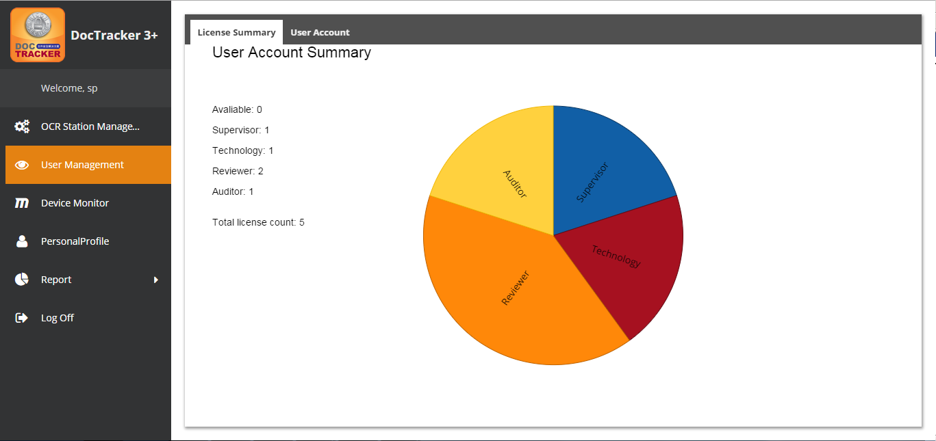

## User Management

Supervisor can define the role of the Reviewer and the Auditor, and specify its accessible group permission.

## Add New User

To add a new user, go to the tab, click the button, and the following screen will pop up:

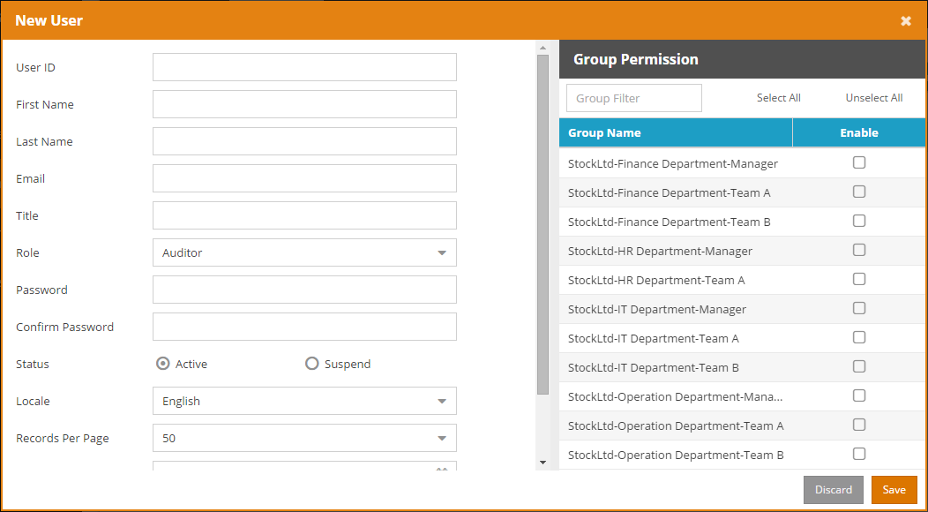

The functions of each field and button are listed below:

|  |  |
| --- | --- |
| Field / Button | Description / Function |
| User ID | The unique Login ID for the user. |
| First Name | The first name of the user. |
| Last Name | The last name of the user. |
| Email | The email address of the user. |
| Title | The title of the user. This can be blanked. |
| Role | The Reviewer user can view the document, to define sensitive keywords, and the security level. The Auditor user can only able to view the document in the defined audit period. |
| Password | The password for the user. |
| Confirm Password | Re-type the password for the user. |
| Status | The status of the user. “Active” enables the user to logon to the system. “Suspend” disables the user to access the system. |
| Locale | The language for the User Interface. It can be “English”, “Simplified Chinese” or “Traditional Chinese”. |
| Records Per Page | The number of records shown on each page. The value ranges from 10 to 60. |
| Auditor End Date | The date which the user will not be able to login to DocTracker. |
| View Doc Start | The beginning date which the user able to view the document |
| View Doc End | The end date which the user will not be able to view the document. |
|  | Press this button to leave this page without adding the user. |
|  | Press this button to create the user with the input information. |

## Update User

To update the user properties, select the user and click the button or double click the user to bring up the following update user screen:

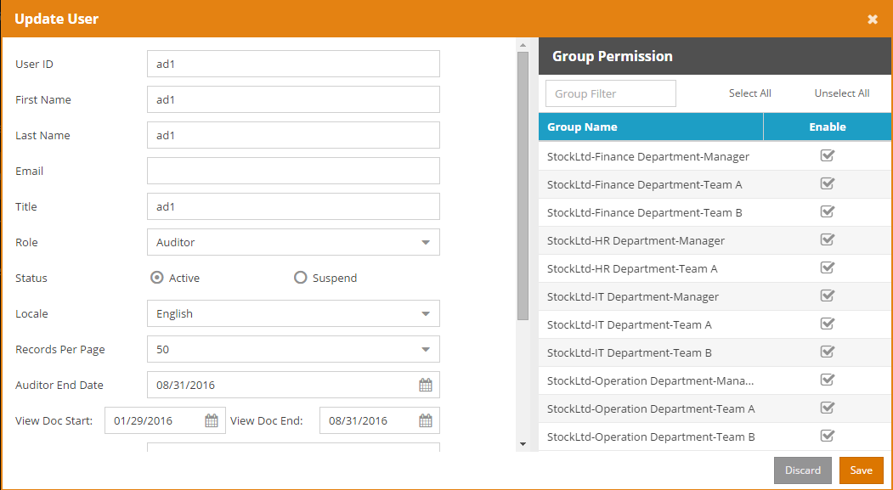

Once the modification is made, click the button to save the changes. Click the button to exit the screen without saving.



## Delete User

To delete a user, select the user and click the button. A confirmation message will prompt the user to confirm the deletion of the user as below.

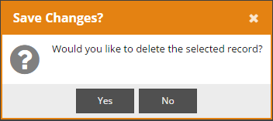

Click the button to delete the user or click the button to cancel the deletion.



## Reset Password

To reset password of a specific user, select the user and click the button to bring up the following Reset User Password screen:

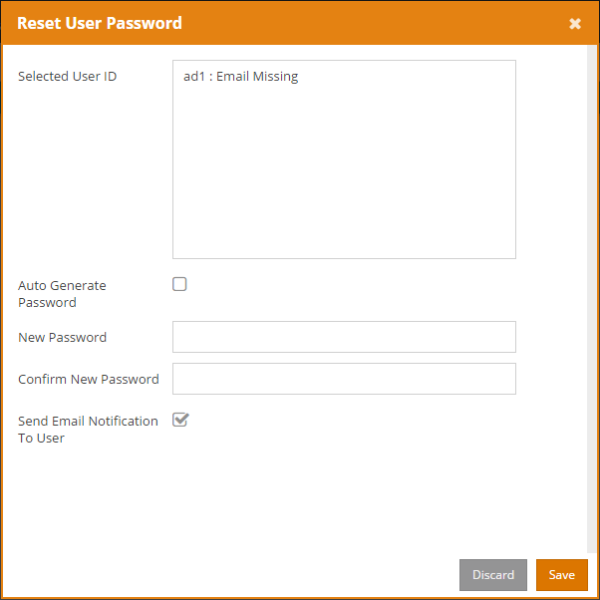

Click the button to reset. Click the button to exit the screen without resetting the password. The following table describes the fields in the Reset User Password screen:



|  |  |
| --- | --- |
| Field | Description |
| Selected User ID | The user which is currently selected, and states if the user has an email address |
| Auto Generate Password | Auto generates a password and sends to this user via email. |
| New Password | Customize a password for this user. |
| Confirm New Password | Re-enter the password. |
| Send Email Notification To User | Specify whether to send email to this user. |

## View Group (except MFP)

To view Access Map User Mapping for Access Map Permission, or to view AD OU Mapping for AD / OU Permission, click the button to view the groups and their users.



# Reviewer and Auditor’s Function

Once login, DocTracker main page will show the Dashboard as below, displaying the summary:

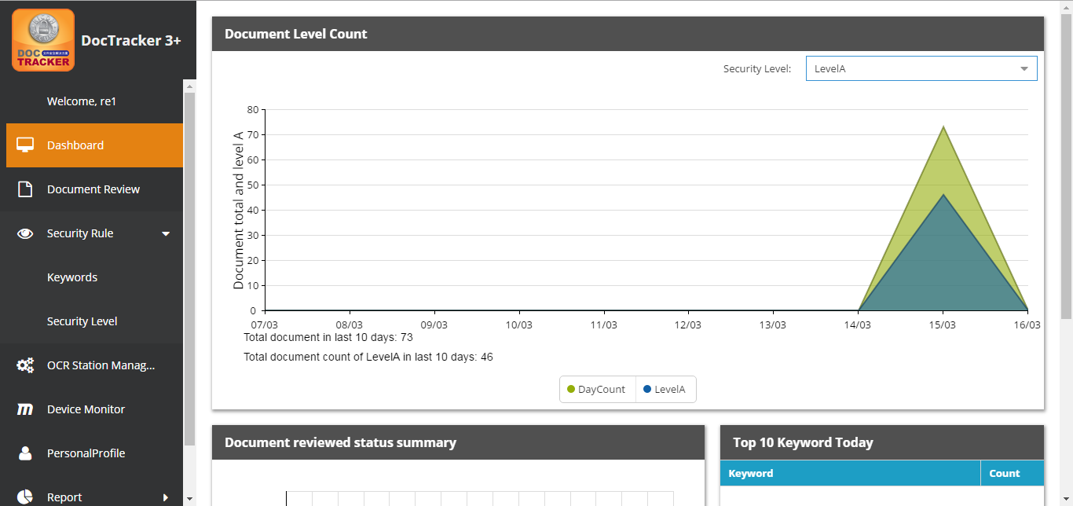

## View Document

DocTracker supports dual authentication when a user views a document. Before viewing a document, authentication of two users is required. After clicking Document Review in the navigation bar, documents that are created on that day will be listed as below. Users can select any dates to view the documents of that day.

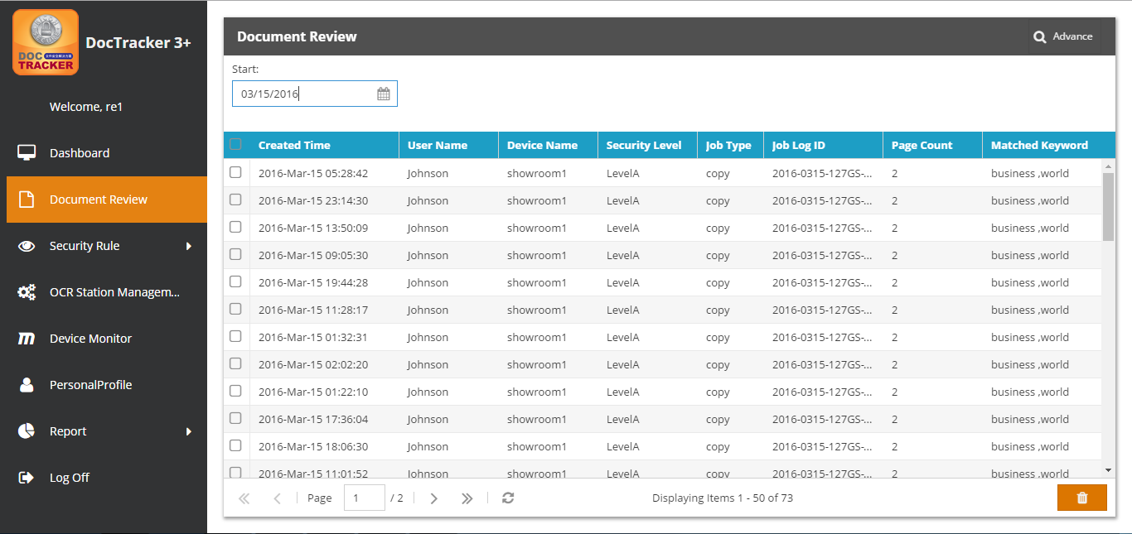

To view a document, double click on a document and the following screen will be shown:

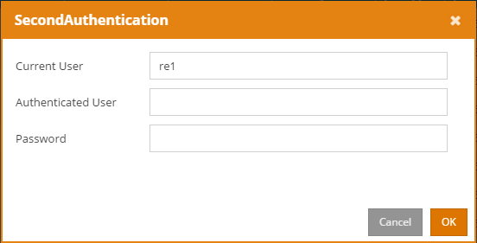

The functions of each field and button are listed below:

|  |  |
| --- | --- |
| Field / Button | Description / Function |
| Current User | The user who is currently login |
| Authenticated User | The second user who has the same permission of the document |
| Password | The password of the second user |
|  | Click this button to leave the page. |
|  | Click this button to authenticate. The content of the document will be displayed if the authentication is succeeded. |

In order to view the content of the document, the system will require another user to authenticate. Once authentication is succeeded, the content and the metadata of the document will pop up as below:

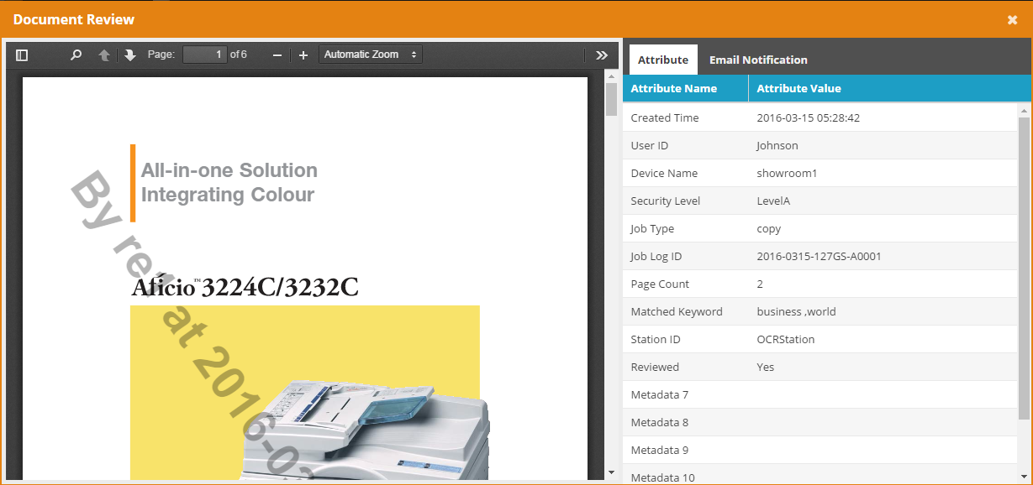

The document content with the watermark will be shown in the left panel. Users can zoom in, zoom out, search the content, rotate the document, etc. with the tool bar on the top of the left panel. The Attribute tab in the right panel will show the metadata which is taken from the metadata file created by the GlobalScan NX. The Email Notification tab will show the email notification record of the document.

## Advance Search

To perform a specific search, click the button, and the following screen will be shown. Users can fill in the criteria, and click the button and perform the search.

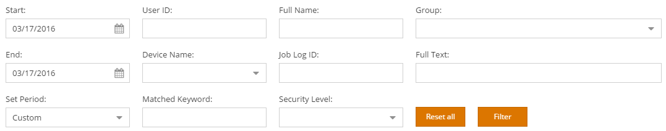

## Delete Document

In order to delete the document in DocTracker, dual authentication is required. Select the desired document, and click the button. A confirmation message will prompt the user to confirm the deletion of the document as below.

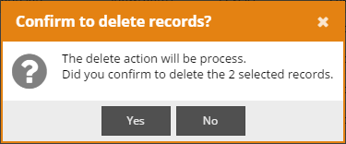

Click the button to delete the document or click the button to cancel the deletion.



# Security Rule (Reviewer Only)

When DocTracker recognizes the sensitive keywords in the saved document, an email notification by default will be sent to the reviewer of that group.

## Keyword

Click the Keyword under Security Rules in the navigation bar will show the following screen:

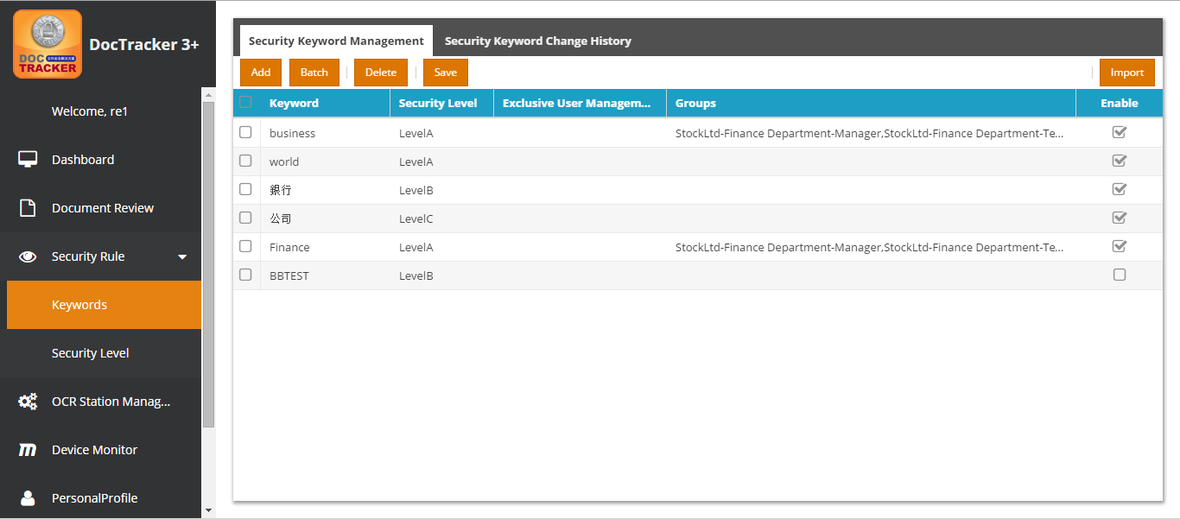

## Add New Keyword

To add a new keyword, click the button and a new entry will be created.



## Modify Keyword

The descriptions of each field are listed below:

|  |  |
| --- | --- |
| Field | Description |
| Keyword | Sensitive keyword of any languages. Click to modify the keyword. |
| Security Level | Security Level of the sensitive keyword. Default Levels are A, B, and C. Click to modify the security level. |
| Exclusive User Management | The document that is uploaded by the exclusive user will be ignored. |
| Groups | Only the document that is uploaded by the defined group will be recognized. Double click to modify the groups. |
| Enable | Check this box to activate the keyword. |

## Batch Update

To batch update the keyword entries, select desired entries to update and click the button, and the following screen will pop up:

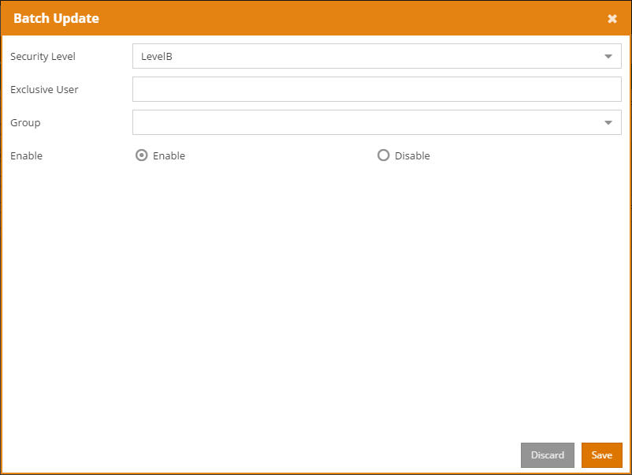

Once the modification is made, click the button to save the changes for all selected entries. Click the button to exit the screen without saving.



## Delete Keyword

To delete keywords, select one or more entries and click the button.



## Import Keyword

Keywords can be imported from a CSV file. To import, click the button.



Browse the CSV file and click the button.

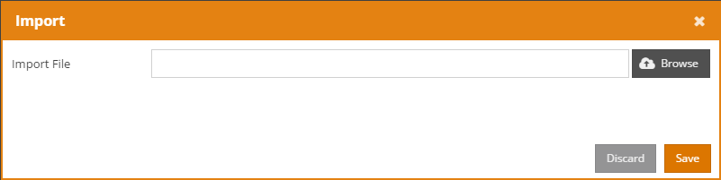

A confirmation message will pop up as below. Click to import the keyword, or click to cancel.

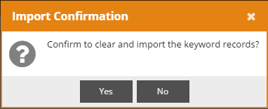

## Keyword History

To view the keyword history, click the tab, and the following screen will be shown:

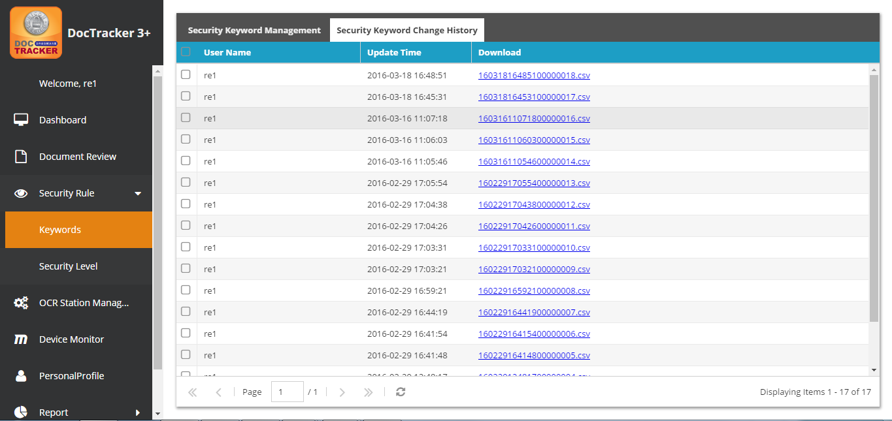

The descriptions of each field are listed below:

|  |  |
| --- | --- |
| Field | Description |
| User Name | The user who update the keyword |
| Update Time | The date and the time of the update |
| Download | Double click to download the CSV file of the keyword to your workstation. |

## Security Level

Sensitive keyword by default has three levels: A, B, and C. If a Level A sensitive keyword is found, an email notification will be sent immediately. If a Level B sensitive keyword is found, an email notification will be sent according to the defined time in the system setting. If a Level C sensitive keyword is found, no email notification will be sent. The default security levels cannot be modified.

Click the Security Level under Security Rules in the navigation bar will show the following screen:

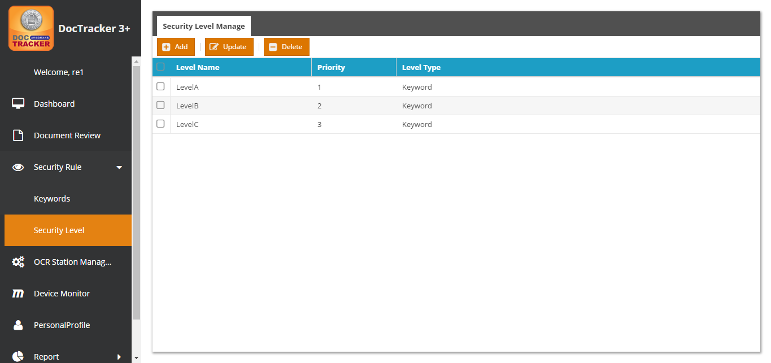

## Add New Security Level

To add a new security level, click the button and the following screen will pop up:

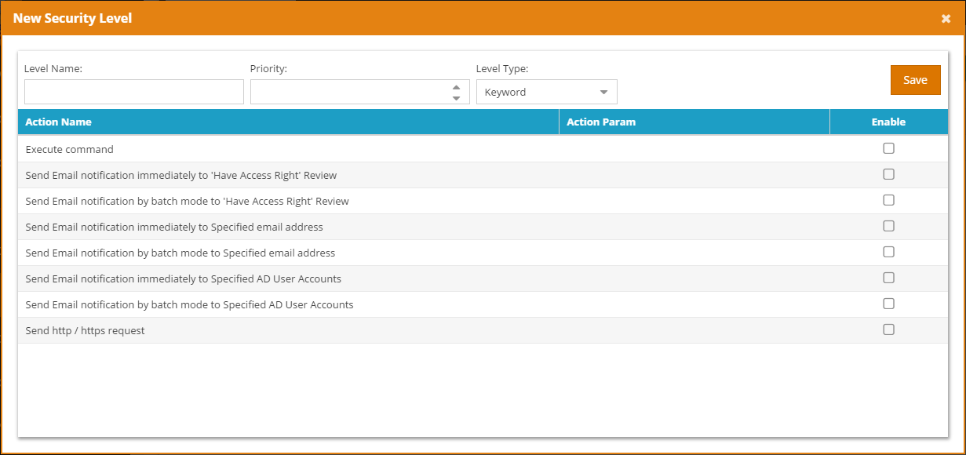

The functions of each field and button are listed below:

|  |  |
| --- | --- |
| Field / Button | Description / Function |
| Level Name | The unique name of the security level |
| Priority | The sequence of the security level for checking |
| Level Type | Only “Keyword” is useable currently |
|  | Press this button to create the security level |

## Update Security Level

To update a security level, select the security level and click the button and the following screen will pop up:

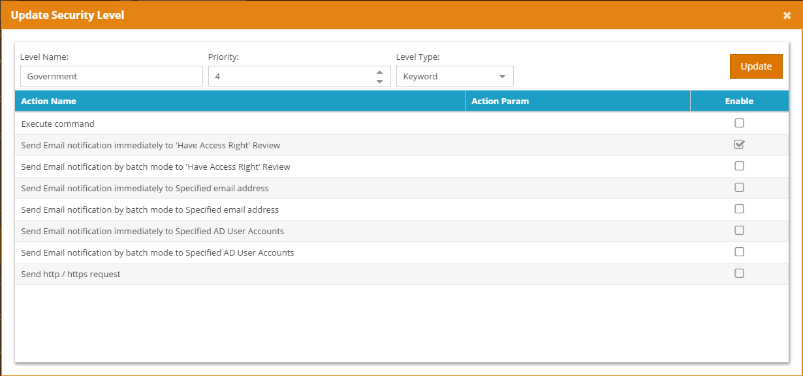

Once the modification is made, click the button to save the changes.



## Delete Security Level

To delete security levels, select one or more entries and click the button. A confirmation message will prompt the user to confirm the deletion of the security level as below.



Click the button to delete the security level or click the button to cancel the deletion.



# General Function

Except for specific functionality as mentioned in previous chapters, every user, regardless of his/her role, is able to use the general function as below.

## View OCR Station Setting

Users can view OCR Station status, but not able to modify the setting. To view the status, click OCR Station Management on the navigation bar, and the following screen will show. At the OCR Station Setting tab, users can view OCR Station ID, IP address, Port, and interval time, etc.

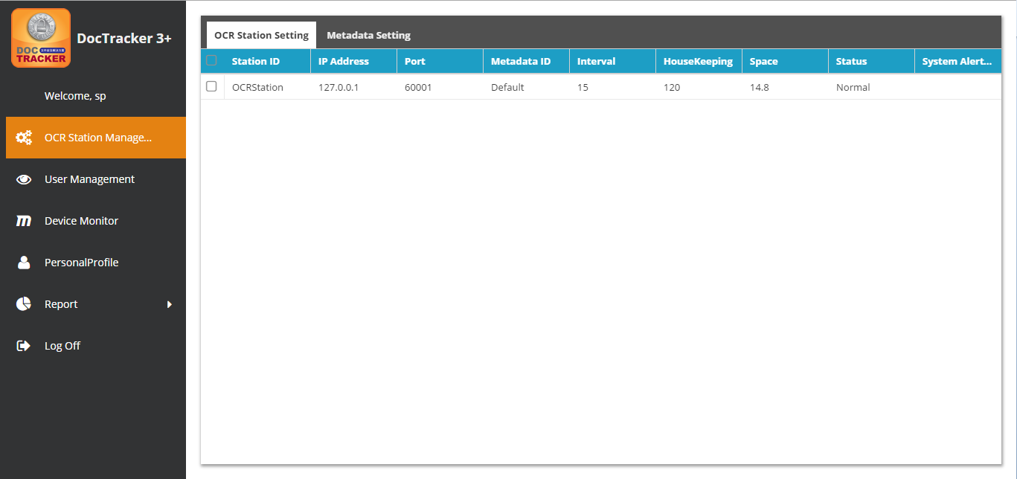

The descriptions of each field are listed below:

| **Field** | **Description / Function** |
| --- | --- |
| Station ID | OCR server unique name |
| IP Address | OCR server IP address |
| Port | OCR server platform’s connection port |
| Metadata ID | Metadata to be used in the OCR server |
| Interval | The interval time (in minute) to monitor the specific folder for OCR server. |
| HouseKeeping | The time period (in month) to keep the information in the OCR server |
| Space | Available space (in GB) in OCR server |
| Status | The connection status between the DocTracker server and the OCR server |
| System Alert to User | If OCR server is disconnected, specified DocTracker user will receive an email notification |

## View Metadata Setting

Users can view OCR Station metadata by clicking the tab, and the following screen will be shown.

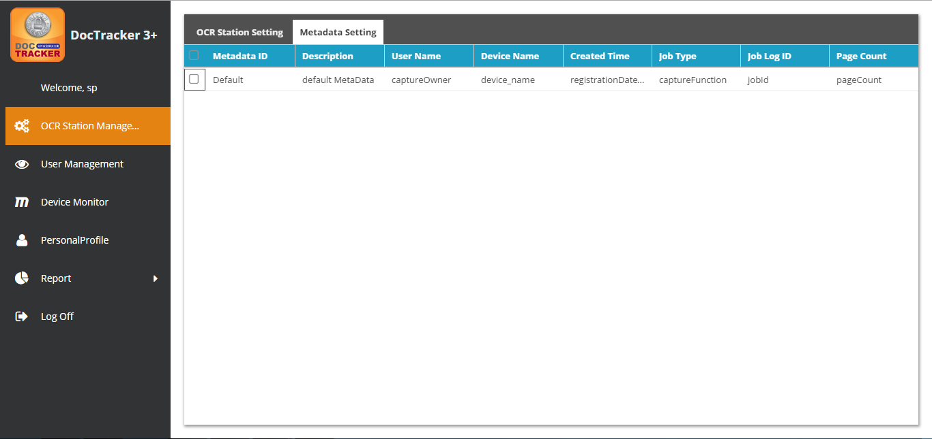

The descriptions of each field are listed below:

|  |  |
| --- | --- |
| Field | Description |
| Metadata ID | The unique name for Metadata setting file. |
| Description | Metadata setting file’s description |
| User Name | The user name of the GlobalScan NX metadata file. |
| Device Name | The device name of the GlobalScan NX metadata file. |
| Created Time | The create date and time of the GlobalScan NX metadata file. |
| Job Type | The job type of the GlobalScan NX metadata file. |
| Job Log ID | The job log ID of the GlobalScan NX metadata file. |
| Page Count | The page count of the GlobalScan NX metadata file. |

## Device Monitor

The Device Monitor displays the number of printed documents, the number of copied documents, the number of scanned documents, and the number of faxed documents.

## Personal Profile

Users are able change their personal profile setting as the screen below:

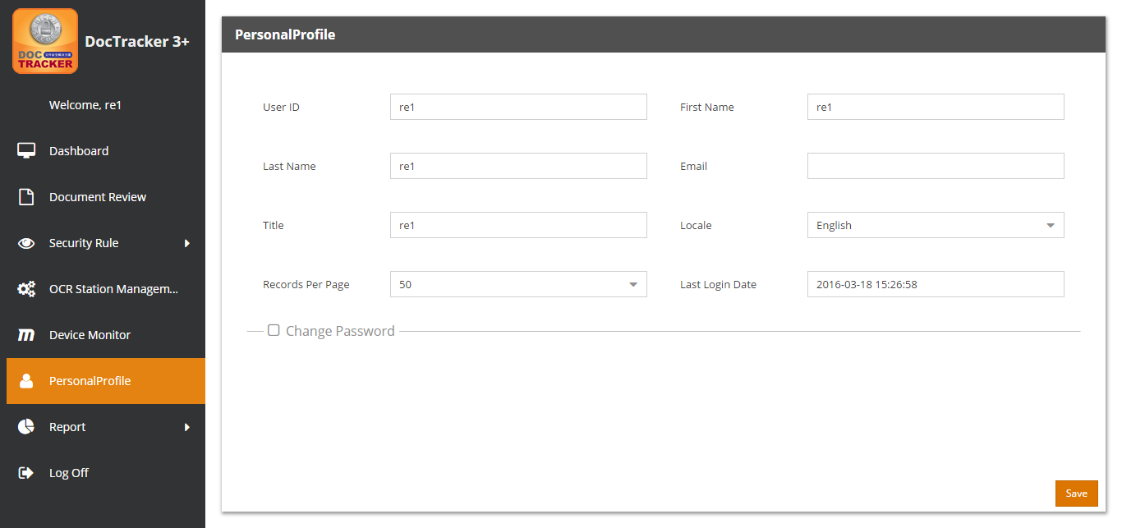

The functions of each field and button are listed below:

|  |  |
| --- | --- |
| Field / Button | Description / Function |
| User ID | The unique ID for the user |
| First Name | The first name of the user |
| Last Name | The last name of the user |
| Email | The email address of the user |
| Title | The title of the user. |
| Locale | The language for the user interface. It can be “**English**”, “**Simplified Chinese**” or “**Traditional Chinese**”. |
| Records Per Page | The number of records shown on each page. The value ranges from **10** to **60**. |
| Last Login Date | The date and time when the user lastly accessing the system. |
|  | Check the box to change the current password. |
|  | Click this button to save the profile seting. |

If is checked, the password changing section will pop up in the Personal Profile as below. Enter the current password, a new password, and confirm the new password accordingly and click to apply the change.

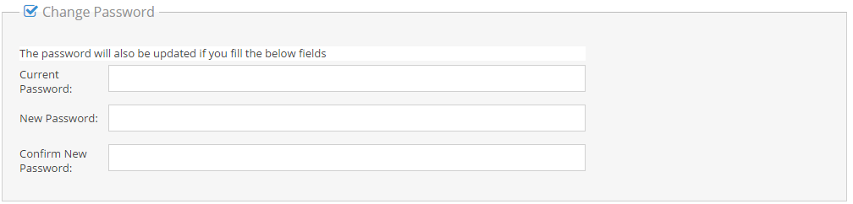

## Report

To create different types of system report, click Report under the Report in the navigation bar, and the following screen will pop up:

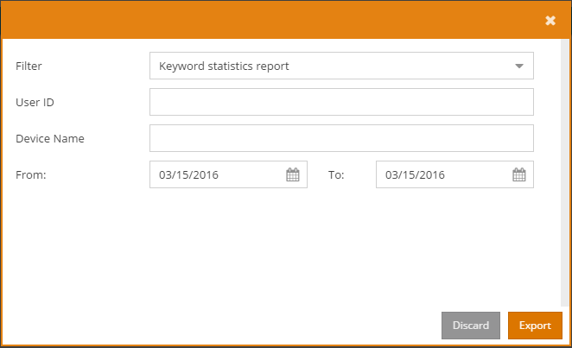

The functions of each field and button are listed below:

|  |  |
| --- | --- |
| Field / Button | Description / Function |
| Filter | Report to be created, i.e. “Keyword statistics report”, “Images storage report”, “Device images storage daily report”, “Items matching report”, “Forced Logout report”, and “User account list” |
| User ID | User ID |
| Device Name | Device Name |
| From | Start date of the report |
| To | End date of the report |
|  | Press this button to leave this page |
|  | Press this button to export the excel report |

## Audit Trail

DocTracker records the activity of every document. None of the DocTracker users are able to modify or delete any entries in Audit Trail. To view the audit trail, click the Audit Trail under Report in the navigation bar, and the following screen will be shown:

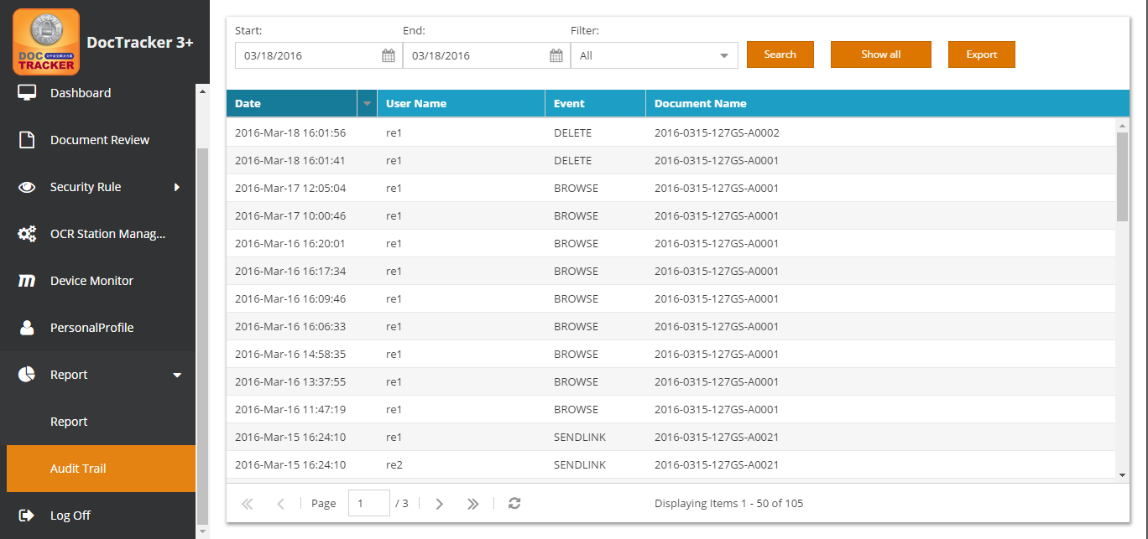

The functions of each field and button are listed below:

|  |  |
| --- | --- |
| Field / Button | Description / Function |
| Start | The beginning date of the search |
| End | The end date of the search |
| Filter | Display the specific event of the audit trail, which includes, All, Browse, Delete, and Send Link |
|  | Click this button to perform the search with selected criteria |
|  | Click this button to display all the activities that occurred in the system |
|  | Click this button to export the audit trail as excel file |